**Homework Practice: Week of March 2**

**Due on Friday, March 6**

***Rotations***

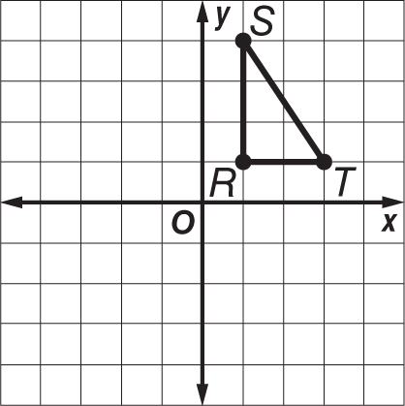

**1.** Triangle *RST* has vertices *R*(1, 1), *S*(1, 4), and *T*(3, 1). Graph the figure and its rotated image after a clockwise rotation of 180° about the origin. Then give the coordinates of the vertices for triangle *R*ʹ*SʹTʹ*.

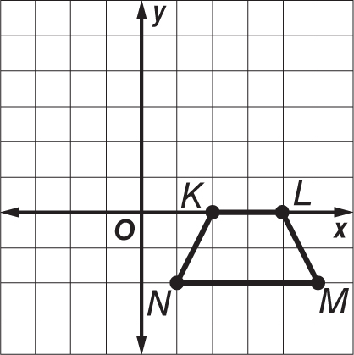

**2.** Quadrilateral *KLMN* has vertices *K*(2, 0), *L*(4, 0), *M*(5, –2), and *N*(1, –2). Graph the figure and its rotated image after a counterclockwise rotation of 90° about the origin. Then give the coordinates of the vertices for quadrilateral *K*ʹ*L*ʹ*M*ʹ*N*ʹ.

**Find the coordinates of the vertices of each figure after a dilation with the given scale factor *k*. Then graph the original image and the dilation.**

**3.** *S*(–2, 1), *U*(0, 1), *N*(–1, –1);  **4.** *M*(–3, 1), *A*(1, 3), *T*(2, –2), *H*(–4, –2); 

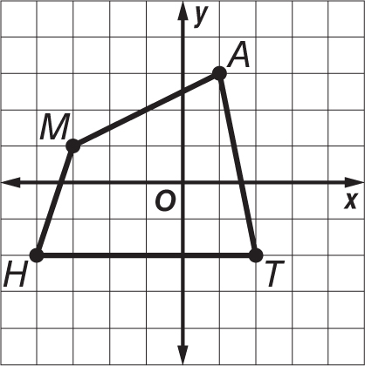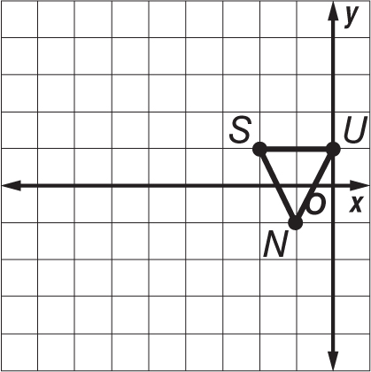

**5. MAPS** Rachel and her cousin, Lena, live in different cities that are about 100 miles apart. On a map, the two cities measure 5 inches apart. What is the scale factor used for the map?

**6. GEOMETRY** A square has vertices *J*(–1, 4), *U*(5, 4), *M*(5, –2), *P*(–1, –2). After a dilation, square *JUMP* has vertices *J*(–0.5, 2), *U*(2.5, 2), *M*(2.5, –1), *P*(–0.5, –1). What is the scale factor of the dilation?