Homework Practice: Week of March 9
Due Friday, March 13

Congruence
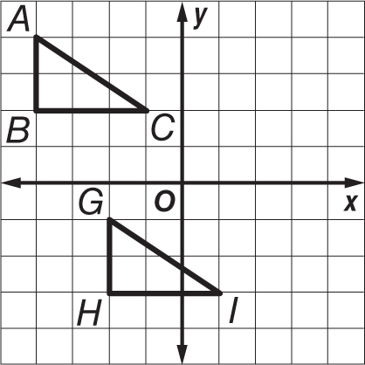
1. Triangles ABC and GHI are congruent. Write congruence statements comparing the corresponding parts. Then determine which transformation(s) map ∆ABC onto ∆GHI.

2. Parallelograms CAMP and SITE are congruent. Write congruence statements comparing the corresponding parts. Then determine which transformation(s) map parallelogram CAMP onto parallelogram SITE.
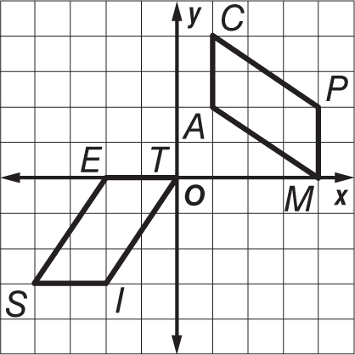

Determine whether each pair of polygons is similar. Explain.

3.. 4.
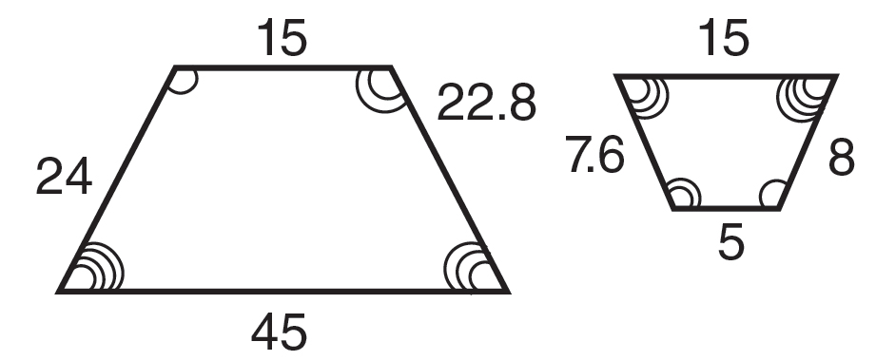
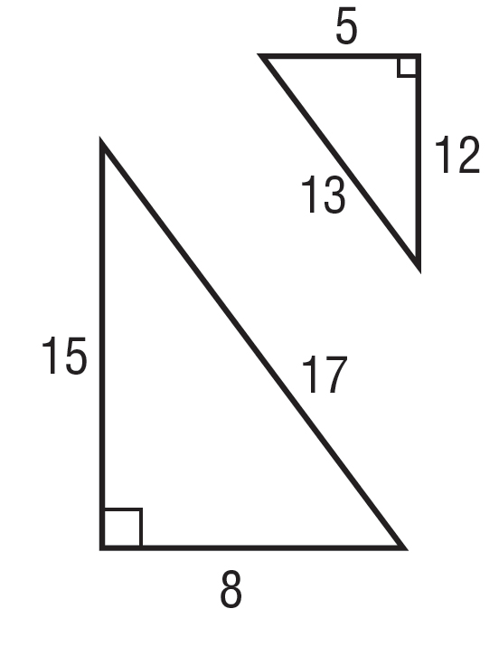

Each pair of polygons is similar. Find each missing side measure.
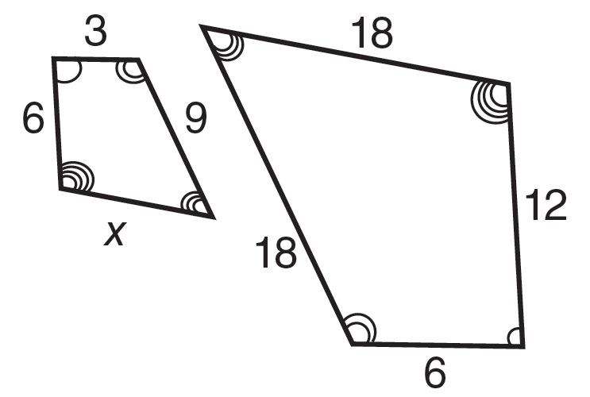
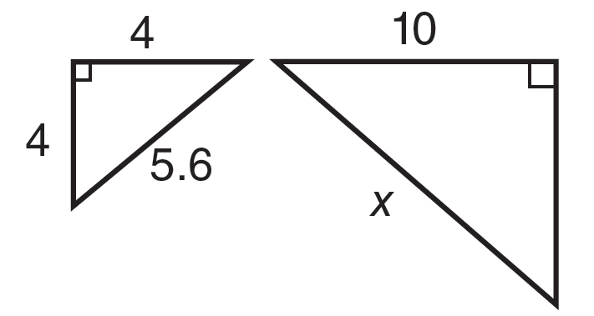
5. 6.

In Exercises 7 and 8, the triangles are similar. Write a proportion and solve the problem.

7. TREES How tall is Yori?
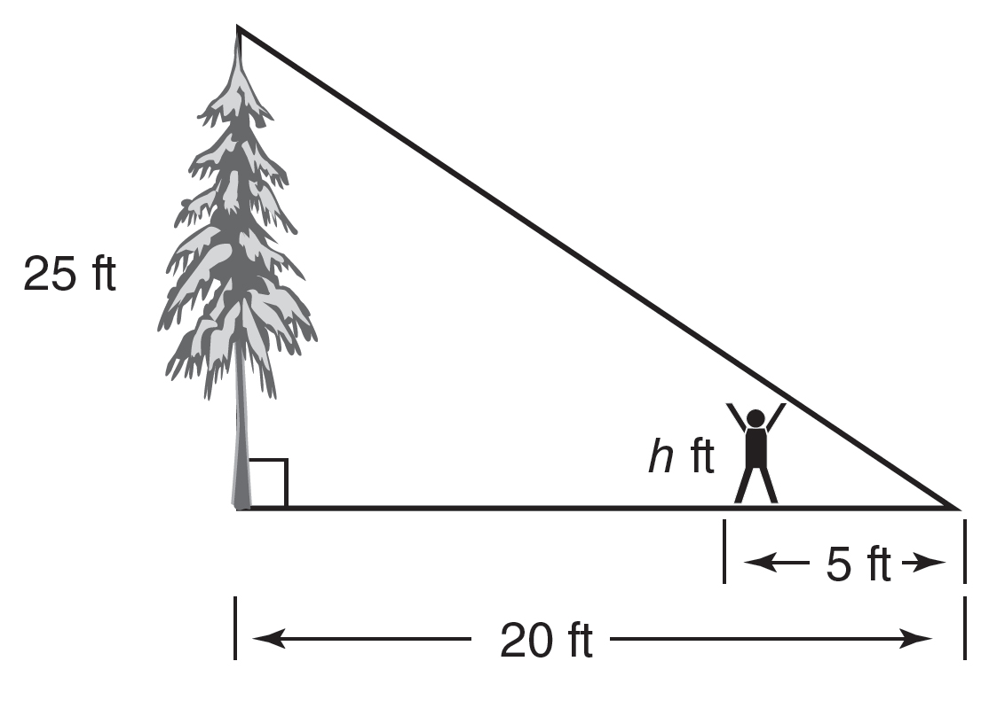
8. TREASURE HUNT How far is it from the hut to the gold coins?

